**CNN MODELS**

**AlexNet:**

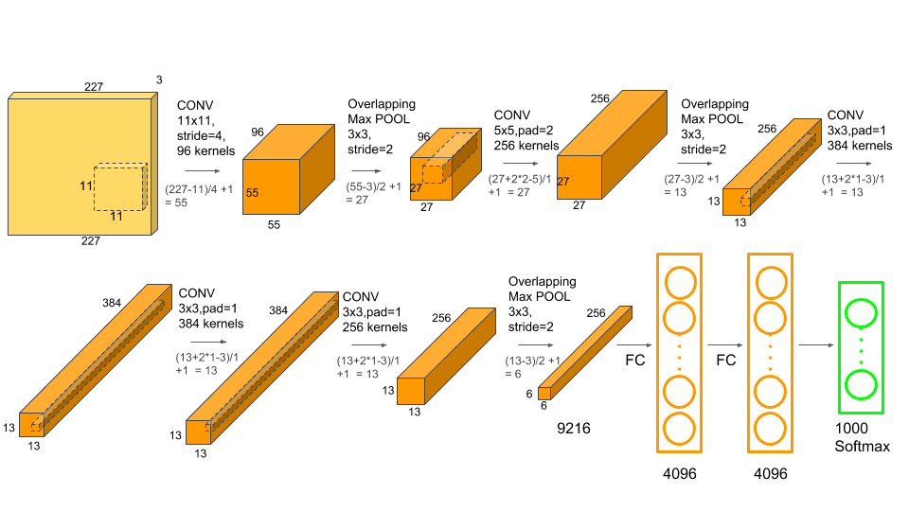 AlexNet is a groundbreaking convolutional neural network (CNN) architecture, developed in 2012 by Alex Krizhevsky, Ilya Sutskever, and Geoffrey Hinton, that achieved a significant breakthrough in image recognition by winning the ImageNet Large Scale Visual Recognition Challenge (ILSVRC).

## **Architecture of AlexNet:**

AlexNet consists of **eight layers**, with five convolutional layers (Conv) followed by three fully connected layers (FC). It introduced **ReLU activation**, **dropout**, and **overlapping max pooling**, which made deep learning models more practical and effective.

**Input Layer**

* The model takes an **RGB image of size 227×227×3** as input.

## **Key Features and Innovations in AlexNet:**

1. **ReLU Activation**:
   * Used **Rectified Linear Unit (ReLU)** instead of **sigmoid or tanh**, which improved training speed and helped mitigate vanishing gradient issues.
2. **Overlapping Max Pooling**:
   * Instead of standard pooling, **overlapping pooling** (stride < filter size) helped reduce overfitting.
3. **Dropout Regularization**:
   * Introduced **dropout** in fully connected layers to reduce overfitting by randomly turning off neurons during training.
4. **GPU Acceleration**:
   * First deep learning model to be trained on **two GPUs**, significantly reducing training time.
5. **Data Augmentation**:
   * Used **random cropping, flipping, and contrast normalization** to artificially increase the training data size and reduce overfitting.

## **Impact of AlexNet:**

* **Breakthrough in Deep Learning**: Showed that deep networks could outperform traditional methods in computer vision.
* **Led to Modern CNN Architectures**: Inspired **VGGNet, ResNet, EfficientNet,** and other advanced models.
* **Proved GPUs are Essential**: Demonstrated that neural networks could be efficiently trained using GPUs.

### **Conclusion:**

AlexNet was a **breakthrough CNN model** that played a critical role in advancing deep learning in computer vision. It introduced several key concepts such as **ReLU, dropout, and GPU training**, which have influenced many modern deep learning architectures.

**VGGNet:**

**VGGNet** is a deep **Convolutional Neural Network (CNN)** architecture developed by the **Visual Geometry Group (VGG) at the University of Oxford** in **2014**. It was introduced by **Karen Simonyan and Andrew Zisserman** in the paper "Very Deep Convolutional Networks for Large-Scale Image Recognition."

VGGNet was one of the top-performing models in the **ImageNet Large Scale Visual Recognition Challenge (ILSVRC-2014)** and is known for its **deep yet simple architecture**.

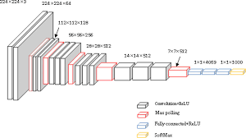

## **Key Features of VGGNet:**

1. **Deep Architecture:**
   * **Uses 16 to 19 layers, deeper than AlexNet (which has only 8 layers).**
2. **Small 3×3 Convolutions:**
   * **Instead of large filters, VGGNet stacks multiple 3×3 convolutional layers, increasing depth while keeping computations efficient.**
3. **Uniform Architecture:**
   * **Uses only 3×3 convolutional filters and 2×2 max-pooling layers throughout the network, making it easy to implement and understand.**
4. **Pretrained Models:**
   * **VGG16 and VGG19 are widely used as pretrained models for transfer learning in deep learning tasks.**

## **VGGNet Architecture:**

**There are two popular versions:**

* **VGG16 (16 layers)**
* **VGG19 (19 layers)**

## **Advantages of VGGNet**

**✅ Simplicity – Uses only 3×3 convolutions and 2×2 max-pooling throughout.  
✅ Transfer Learning – Pretrained models like VGG16 and VGG19 are widely used in real-world applications.  
✅ Better than AlexNet – Higher accuracy due to deeper layers and better feature extraction.**

## **Disadvantages of VGGNet**

**❌ Large Number of Parameters – VGG16 has 138 million parameters, making it computationally expensive.  
❌ Slow Training Time – Due to its deep architecture and large parameter count, it takes more time and memory to train.  
❌ Outperformed by Modern Architectures – Models like ResNet, EfficientNet, and MobileNet perform better with fewer parameters.**

## **Conclusion:**

VGGNet was a significant **breakthrough in deep learning**, proving that **deeper networks** can achieve better results. While newer architectures like **ResNet and EfficientNet** have surpassed it, **VGG16** remains a popular choice for **transfer learning** and **feature extraction** in computer vision tasks.

**DenseNet:**

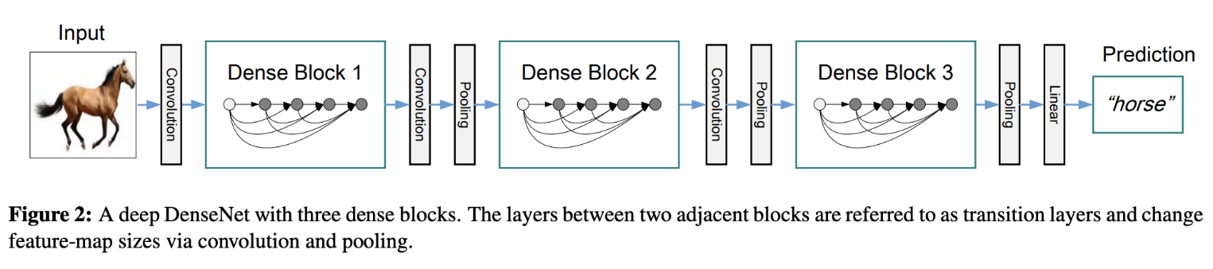 (Densely Connected Convolutional Network) is a convolutional neural network architecture where each layer connects to every other layer in a feed-forward fashion, enabling feature reuse and improving gradient flow, ultimately leading to better performance and parameter efficiency.

* **Dense Connectivity:**

Unlike traditional CNNs where each layer only connects to its immediate neighbors, DenseNet connects each layer to every other layer in the network.

* **Feature Reuse:**

This dense connectivity allows each layer to receive feature maps from all preceding layers as input, promoting feature reuse and enabling the network to learn more effectively.

* **Improved Gradient Flow:**

The dense connections also help alleviate the vanishing gradient problem, a common issue in deep neural networks, by providing more direct paths for gradients to flow through the network.

* **Reduced Parameters:**

DenseNet can achieve comparable or even better performance than traditional CNNs while requiring fewer parameters, making it more efficient.

* **Dense Blocks:**

DenseNets are structured into "Dense Blocks", which are groups of convolutional layers with dense connections within the block.

* **Transition Layers:**

Between Dense Blocks, "Transition Layers" are used to reduce the number of feature maps and the spatial resolution, which helps to manage the computational complexity.

* **Advantages:**
  + **Alleviates Vanishing Gradient Problem:** The dense connections provide multiple paths for gradients to flow, reducing the risk of gradients vanishing or exploding during training.
  + **Strengthens Feature Propagation:** By concatenating feature maps from all preceding layers, each layer receives a rich set of features, leading to better feature propagation and representation learning.
  + **Encourages Feature Reuse:** The dense connections allow the network to reuse features learned in earlier layers, leading to more efficient learning and generalization.
  + **Substantially Reduces Parameters:** DenseNets can achieve comparable or better performance with fewer parameters than traditional CNNs, making them more computationally efficient.
* **DenseNet-121:**

A specific implementation of DenseNet with 121 layers, commonly used in image classification tasks.

* **DenseNet-201:**

Another implementation of DenseNet with 201 layers, also used in image classification tasks

**CONCLUSION:**

Dense Convolutional Network (DenseNet), connects each layer to every other layer in a feed-forward fashion. Whereas traditional convolutional networks with L layers have L connections - one between each layer and its subsequent layer - our network has L(L+1)/2 direct connections. For each layer, the feature-maps of all preceding layers are used as inputs, and its own feature-maps are used as inputs into all subsequent layers. DenseNets have several compelling advantages: they alleviate the vanishing-gradient problem, strengthen feature propagation, encourage feature reuse, and substantially reduce the number of parameters.